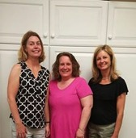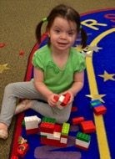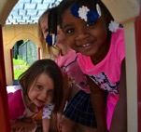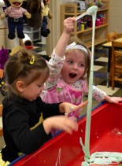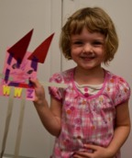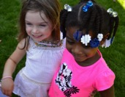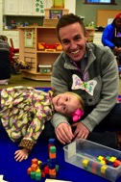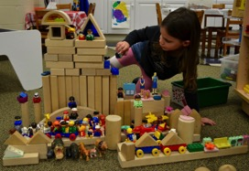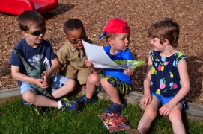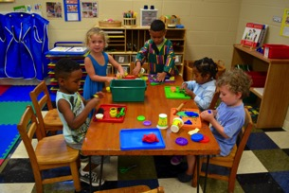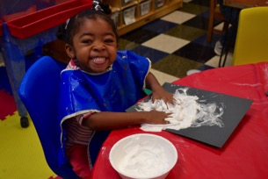

Grace Church  
Preschool

1815 Hall Street

Grand Rapids, MI 49506

(616) 242-3202

FAX # (616) 241-5306

[www.gracechurchgr.org](http://www.gracechurchgr.org)

Or find us on Facebook: Grace Church Preschool

**Our Staff**

All of our teachers are educated in Early Childhood Development.

***Ms. Jill*** is our Director and Lead Teacher at Grace Church Preschool. She teaches all of the classes. She has a Masters Degree in Early Childhood Education and has had 22years of experience in Child Care and in Preschool and Kindergarten classrooms.

***Ms. Kathy*** is our MWF Lead Teacher at Grace Church Preschool. She has a Masters Degree in Early Childhood Education. Miss Kathy was our Young Five’s teacher for 2 years. She will be teaching her second year of preschool and has 6 years of experience in education.

***Miss Cara*** is our T/TH Lead Teacher at Grace Church Preschool. She has a Masters Degree in Early Childhood Education. She has 9 years of experience in education. She will also be teaching the Young Five’s Music Class. Miss Cara has taught one year of preschool at GCP.

All of our teachers are certified in CPR and First Aid.

***About Us:*** We are Grand Rapids’ oldest preschool, serving the community since 1950. We are licensed by the state of Michigan and we operate as a non-profit ministry of Grace Episcopal Church. We are located in a large cheerful area in the church’s lower level. Grace Church Preschool is ready to serve you and your preschooler!

***Our Philosophy:*** We believe that each child is a unique individual, created in the image of God. We know that the early years in a young child’s life are the most important years for learning, loving and gaining trust. We provide a warm, welcoming and caring Christian atmosphere, a devoted staff and positive learning environment that encourages the intellectual, social, emotional, spiritual, physical and creative development of each child.

***Mission Statement:*** We believe that play is the most important activity in the lives of children. Through a variety of learning experiences, activities and multi-cultural materials, children will build understanding, empathy, self-identity and a positive self-image.

***Class Options and Tuition***

Morning Classes 9:00 to 11:30 AM  
Tuesday and Thursday (2 days)  
$145.00/month - $1,305.00/year

Monday, Wednesday, Friday (3 days)  
$205.00/month - $1,845.00/year

Afternoon Classes 12:30 to 3:00 PM  
Monday, Wednesday, Friday (3 days)  
$205.00/month - $1,845.00/year

All Day Classes 9:00 AM to 3:00 PM  
Monday, Wednesday, Friday (3 days)  
(Children bring a bag lunch)  
$395.00/month - $3,555.00/year

Our classes are all multi-age, open to children three, four and five. Children must be three by September 1, 2017 and self-sufficient in their toileting.

Classes begin Tuesday, September 5 and Wednesday, September 6, 2017. An orientation day for each class will be held prior to the first day of school.

**We are a Christian Preschool and our curriculum is built on themes and takes into account children’s interests. The classroom is set up with learning centers and interest areas where the children can touch, feel, experiment and create. Children work in large and small groups making choices, problem solving, learning to cooperate, expanding and refining language, taking responsibility, developing social skills and building confidence. We practice our class rules, which are “Be Kind”, “Be Fair”, and “Be Safe.” We will share stories from the Bible which will be reinforced with crafts and activities and praising God through song. We will be using Zoo-phonics curriculum to learn letters and sounds. This program fully involves the child’s eyes, ears, mouth and body as they learn phonemic awareness and early pre-reading skills. We also use the Handwriting Without Tears curriculum to teach children how to form and write their letters.**

Small groups

Exploration time

Bible story

Outside play

Dismissal

***Our School Year***

Our preschool operates from September to May following East Grand Rapids School calendar in regards to school closings, seasonal breaks, and holidays. During the summer, a packet of information and forms will be mailed to you and must be returned by orientation.

***Registration***Registration begins in January for classes beginning the following September. Fall classes are open to current enrolled families, church members, alumni and community. Please call for these dates and times. A $60.00 non-refundable enrollment fee and the first month’s tuition are required when enrolling.

***A Typical Day***

Arrival

Circle time

Music and movement

Story time

Prayer

Snack

# Our Curriculum